Ninfield Parish Council Submission to Wealden District Council in relation to the application WD/2019/1859/MRM Land off Manchester Road, Ninfield
RESERVED MATTERS PURSUANT TO OUTLINE PERMISSION WD/2017/0038/MAO (OUTLINE APPLICATION (WITH ALL MATTERS RESERVED EXCEPT FOR ACCESS FROM MANCHESTER ROAD) FOR UP TO 80 RESIDENTIAL UNITS (INCLUDING 35% AFFORDABLE HOUSING ON-SITE PROVISION), INTERNAL ROADS AND PARKING, PUBLIC FORMAL AND INFORMAL OPEN SPACE, HARD AND SOFT LANDSCAPING TOGETHER WITH SUSTAINABLE URBAN DRAINAGE SYSTEMS)

Objection Summary:
- Response time: we reserve the right to make further comments when all consultee reports become available. The response date we have been given is unacceptably short especially considering there has been no consultation regarding this site since January 2017.
- No meaningful consultation: The parish council and residents have not been consulted on this site since the January 2017 application at which stage the site was outside of the development boundary and not in the WLP proposed submission document.
- Size of the development: 80 dwellings on this site is far too many and would be at a greater density than any other part of the village. Isolated and separated from the rest of the village this would be an intensively urban estate.
- Design: proposed materials are not locally prevalent and are out of keeping with the rest of the village. This plan does not follow “Secured by Design” principles and we have serious concerns for future resident’s safety i.e. an isolated and unoverlooked play area, open drainage ditches (see below). The “shared surface” is unacceptable in a rural village. Fewer dwellings would leave space for paths and verges to separate pedestrians from vehicles. There is a troubling lack of detail on plans throughout the scheme.
- Drainage: new sewerage infrastructure is required to accommodate this estate (as stated by Southern Water). The current foul drainage system is failing existing residents. Surface water drainage proposals involving 3rd party land may constitute water trespass.
- Poor sustainability: this application does not sit well with Wealden’s stated climate change emergency objectives. We can see no solar panels (neither heating or PV), no rainwater harvesting, or car charging points shown on the drawings. The travel plan and parking provision arrangements are seriously flawed. All residents will be car dependent by necessity and these issues must be resolved before the plan is passed to protect the Ashdown Forest, Pevensey Levels and Lewes Downs.
- S106 is incomplete: the document on file does not include East Sussex County Council for highway matters that will impact the whole village. Landowners involved have not even been contacted let alone consulted.
Detailed Evidence on which this objection is based.
Background
The application site, North East of Manchester Road, is on the edge of the High Weald AONB at the highest point of the village some 260ft above sea level giving it a prominent position overlooking the AONB. The entrance to the proposed site is 1.1km to the village shop and post office.
The proposed site entrance, enabled by the demolition of 2 houses, construction of a new road and entrance for all construction traffic is next to Grade ll listed Church Farm Oast and requires access to it passing other listed buildings and a row of ancient, protected Lime Trees on the edge of the road.
Manchester Road is an unclassified rural lane which varies in width from 3.6m to 6m. It is accessed from the A269 by the Blacksmiths pub past Grade ll listed High Knoll including the boundary wall which is also listed, or Coombe Lane, which is also unclassified, abuts ancient woodland and narrows to 2.8m, or Marlpits Lane which is also unclassified and narrows to 3.0m, both of the latter two run along-side the boundary of the High Weald AONB. Furthermore, land assessments by WDC show that Marlpits Lane is an historic routeway with historic field boundaries with mature hedgerows which require protection and must not be removed. The officer report, in the application WD/2019/1040/MAO, refers to an appeal decision in 2015 for 28 new dwellings at Swanpool Road, Cornwall, Ninfield Parish Council considers that this appeal is out of date considering the revisions to the NPPF and other policies since then and the many appeals closer to home which consider the effect on local character and the High Weald AONB.
The Ancient Lime Trees outside Church Barn Farm are covered by a Tree Protection order and date back to at least the Georgian Period and probably before. They are right on the edge of the road and there is no detail on how these trees will be protected. The roots of these trees are under the roadway horizontally and extend more than 2m and therefore highly susceptible to damage.
Site Planning History
The Parish Council are clear that there was no meaningful consultation on this site.
The outline application for this site was submitted back in 2017, WD/2017/0038, and received a large number of local representations. In 2015 members of the Planning Committee South visited the SHELAA sites in the village and overwhelmingly commented on the appalling access to this site from the A269 making it unsuitable for large scale development. At this time the site was not in the WLP proposed submission of March 2017 and was outside the planning boundary.
The monitoring plan issued by WDC December 2018 confirmed a 5-year housing supply. Planning Officers are now reverting to the district not being able to demonstrate a 5-year housing supply but providing no reasons as to what has changed since the December 2018 report.
With no further consultation with the residents of Ninfield or the Parish Council (since the application was consulted on from 11/1/2017 – 01/02/2017), the July 2018 WLP Regulation 19 proposed submission document was published with this site included Land off Manchester Road (RUGA 14).
Representations were invited on the proposed submission document from 13th August to 8th October 2018 but before any objections had been assessed or resolved WDC officers chose to put this application (WD/2017/0038/MAO) for Land off Manchester Road to the Planning Committee South 11th October 2018. The officer report was dated 3rd October 2018 and recommended approval.
The Parish Council are aware that due to legal agreements with the current landowner of the proposed development site, some neighbouring properties are unable to submit their objections to this application. It is not that they do not object or do not have good reason to object, but are restricted in being able to put forward their views’
Great weight was afforded to the emerging WLP and the new Ninfield planning boundary at the Planning meeting, even though it had yet to be submitted to the inspectorate – contrary to Para 48 of the NPPF, which explains that weight may be given to relevant policies in emerging plans according to the stage of the emerging plan, the extent to which there are unresolved objections and the degree of consistency of the relevant policies in the emerging plan to the Framework. Given that the regulation 19 representation period had not closed and there were outstanding objections the weight that can be given to the plan is substantially reduced.
RUGA 14 states that proposals will only be permitted if they meet the following specific requirements and other relevant policies detailed in the development plan.
- A traffic assessment…… including the junction of the A269 and A271 - this does not appear to have been done.
- This should include the protection, retention and enhancement of the existing hedgerows and mature trees. Hedge row in the historic Marlpits Lane is proposed to be removed for an entrance that goes against the Secured by Design principles for safety.
This reserved matters application looks to approve all matters except for site access – this includes considering the number of dwellings on site.
Paragraph 6.2.2 of the developers planning statement claims ‘The Emerging Local Plan has now been formally submitted for examination, therefore, holds some weight in the determination of this planning application. Within the Emerging Local Plan, the site is designated as a housing allocation (NIN 2) within the Ninfield settlement boundary for up to 80 dwellings for the Local Plan Period. The principle of development for 80 new dwellings, including 35% affordable housing, provision of internal roads, parking, and public informal and formal open space, landscaping, sustainable drainage system with primary access was established at the Outline stage’
The weight afforded to the WLP for this site is diminished due to the outstanding objections and the principle of development for 80 houses was not established as quoted, the principle was for up to 80 houses and ALL OTHER MATTERS RESERVED. The outline application was subject to several key conditions that have not been met.
Site Map
The proposed site entrance includes a house in the entrance road which all proposed residents and visitors will pass by. All proposed 80 houses have now been allocated to a 3-hectare field, creating a density of almost 26.67 dwellings per hectare as opposed to the stated density 20.37.
Whilst the Parish Council are pleased to see that the area directly behind the current Manchester Road residents will not be built on it does not add to the quality of their everyday life. Currently they have uninterrupted views of natural green fields where wildlife and flora and fauna live in harmony. This will diminish to a strip of land between themselves and a dense suburban housing estate with a plethora of building materials uncharacteristic of the local area.
The developer is trying to cram the maximum number of dwellings onto the site so there is no room for basic road safety measures such as pathways and verges to separate pedestrians from vehicles. The pedestrian being at additional risk sharing a surface with the silent electric cars. The shared surface concept is widely regarded as dangerous for children and the elderly and has no place in a rural village. The proposed estate road has been realigned bringing it in closer proximity to the northern boundary adjacent to the existing well-established stables; this road as close to where the horses are stabled will result in noise disturbance which will adversely affect the wellbeing of the competition horses within the stables and while they are grazing in the adjoining field.
The proposed pedestrian and cycle exit on to Marlpits Lane, (the far north western part of the site) is contrary to the ‘secured by design’ advice, (as also stated in the police crime prevention officers report). This is a rural unclassified 3.6m wide Lane, reducing to 3m in parts, with no footpaths or lighting. It will also require the removal of a mature hedgerow.
Residents would appear to have to cross drainage ditches to access Informal ‘open space’ on the outskirts of the estate. A small children’s play area does not appear to meet the requirements of LEAP and is not visible from nearby dwellings and is not positioned by a pedestrian route that is well used.
Development Size
The size of this development is greater than any other single development that the village has seen. The cul de sacs currently in the village are 35 dwellings or below. The current proposal of 80 dwellings is unacceptable overdevelopment. It creates an urban feel within a rural village and the estate attempts to suburbanise an unclassified lane. There are no circumstances where a cul de sac of 80 dwellings is in keeping with the character of the village. Whilst the Parish Council acknowledge that this application identifies the types of houses needed in the village, it is far too large.
The social housing need for Ninfield is 11, a figure that has not changed in more than 10 years. In conjunction with other developments approved by WDC there is no justification for this application on green field land. This application is detrimental to the vitality of the village and because it is not needed does not make good use of the land contrary to Paragraph 122 of the NPPF and does not consider the issues with infrastructure.
The proposed development would be a more substantial area of housing creating a greater level of built form, than any part of the village. The intensification of the urban style estate and its associated additional domestication would be harmful to the character and appearance of the area. It would neither conserve nor enhance the landscape, which is currently hedged fields sitting alongside the AONB. The topography of the land, sloping away means that the site will be highly visible from the AONB and the heritage site of Battle abbey. The Planning Practice Guidance clarifies that the duty to ‘have regard’ extends to Land outside the boundary of an AONB. When the trees are bare in the winter months the views are afforded to Ashburnham, and Hastings as well as Battle Abbey and therefore the historical Abbey will also be able to see the proposed site.
This proposal would not comply with NPPF Section 15 policies for conserving and enhancing the natural environment.
Paragraph 170 – Planning Policies and decisions must contribute to and enhance the natural and local environment
- by protecting and enhancing valued landscapes, sites of biodiversity or geological value and soils (in a manner commensurate with their statutory status or identified quality in the development plan).
The size of the proposal will have an eroding impact on the biodiversity with the suburbanisation created during the build process and forever afterwards. The proposals contained will not represent a net gain in biodiversity as required by the NPPF.
Manchester Road including Millfield and Coombe Shaw currently has 121 dwellings in 6.9ha giving a density of 17.5 dwellings per hectare. The proposed site has 80 dwellings on a 3-ha field which gives a density of 26.67 dwellings per ha. This proposal increases the overall number of dwellings by 66% creating an increased density that is unacceptable and out of keeping with the character of the area. The site is on the edge of the village which is characterised by a dwindling number of dwellings and a substantially reduced density of typically 8 – 15 dwellings per ha.
Paragraph 172 of the NPPF states Great weight should be given to conserving and enhancing landscape and scenic beauty in National Parks, the Broads and Areas of Outstanding Natural Beauty, which have the highest status of protection in relation to these issues. A judicial review in respect of a planning permission for a residential development for 31 dwellings, R (Mevagissey Parish Council) v Cornwall Council, sets out the interpretation of paragraph 115 in determining planning applications. Here the judge stated that “the NPPF places the conservation of landscape and scenic beauty of an AONB into a special category of material consideration: as a matter of policy paragraph 115 requires it to be given great weight. This application does not recognise the intrinsic character and beauty of the natural countryside or the character of our village.
Paragraph 6.6.2 of the developers planning statement claims
The site sits on the urban fringe of Ninfield. Within the wider landscape the agricultural fields (to the east) are edged with hedgerows, shaws and tree groups affording only limited longer views of the site. Perceptions of tranquillity are intermittently affected by the proximity of the northern urban edge of Ninfield and Marlpits Lane which is influenced by the visible evidence of equestrian related activities both to fields adjacent to the proposed development site and the site, which detracts from the semi-rural setting.
The Parish Council contend that the rural village setting has a linear development that dwindles in density at the edges of the village and includes farmland and countryside buildings, including stables for horses. which are wholly appropriate for the area and
do not detract from it in contrast to the inappropriate suburban estate.
Whilst the planning officer will quote that the outline permission has been granted BUT it was for ACCESS ONLY from Manchester Road and for UPTO 80 houses. All the evidence presented shows that if 80 houses were given permission the adverse effect on the countryside and the AONB as well as the village of Ninfield would be catastrophic. The development would not maintain the intrinsic value and character of the countryside.
Furthermore, the developer claims WLP 7 (Distribution of Homes) sets out the level of housing across the district to be allocated or identified as a SHELAA site, whilst providing a windfall allowance in each Middle Super Output Area (MSOA).
The site is located within the emerging Ninfield development boundary as a designated housing allocation (Policy RUGA 14, Land at Manchester Road) as of June 2018. The application site is located within the Ninfield Wealden 014 South MSOA, which has a total of 123 housing allocations for the local plan period in which this planning application seeks to deliver 80 of these allocations. WD/2018/2354 noted this as a reason for refusal of one new dwelling from an outbuilding conversion in the countryside.
There are not 80 of these allocations left as there are already 13 approved at Potmans Lane, 3 at Moons Hill and 1 at Standard Hill with up to 45 identified at Land at Crouch UGA 13). To accord with this plan there are no more than 61 housing allocations left. If this application were to be approved, it would be contrary to WLP 7.
Design
The developer claims ‘The proposed appearance of the dwellings consist of high quality contemporary designed properties’
The appropriate design for any dwellings on this site would be in line with the characteristics of the existing houses in Ninfield. This is predominately red brick, red tile roof buildings with tile hung exterior on the upper floor. There are a small number of traditional style weatherboard cottages many of which are listed.
The application site is, as previously identified, surrounded by historic roads, fields and the High Weald AONB which would make the suburban style estate out of keeping. Wealden’s policy EN20 states that proposals for development outside a Conservation Area but which affect its setting or views into or out of it should respect its character and appearance.
The developer states ‘A palette of building materials will be incorporated within the development through the use of brickwork, plain clay tiles, and sweet chestnut cladding to create a variation within the street-scene and emphasis different areas throughout the development. The use of glazing within the development will allow provide more contemporary detailing to add to the proposal’s identity’
The proposed materials are not locally prevalent and are out of keeping with the historic area. This includes but is not limited to, the grey metal coping and balustrades, buff brick blends, metal porch canopies, vertical cladding and aluminium powder coated window frames (which are not low maintenance as they are known to bubble and need repainting).
The High Weald Management plan (HWMP) explains that settlements are characterised by historic buildings with a limited pallet of materials which is typical of Ninfield. The HWMP identifies generic layouts and suburbanisation as some of the top 5 issues facing the landscape. Objective S3 of the Management Plan is ‘To enhance the architectural quality of the High Weald and ensure development reflects the character of the High Weald in its scale, layout and design’
The proposed dwellings include details unrelated to the locality or the building traditions of the wider landscape. The proposed estate has a hard-urban appearance uncharacteristic of the village, and a prominent suburban intrusion in the countryside and AONB landscape. There has been no effort to consider or consult the local community in designing the site and for example the furthest point north east of the entrance on to the estate contains houses designed for wheelchair access which is 300m to the site exit.
Flooding and Drainage
The proposals are weak and do not address the objections from Southern Water via the Regulation 19 representations. The proposal includes drainage onto third party land which has raised objections from the landowner and constitutes water trespass.
Reinforcement of the sewerage network would be required to accommodate this proposal. The Parish Council are also aware of capacity issues. The new infrastructure would be needed in parallel to the development and this has not been secured. Furthermore, residents in Marlpits Lane, Manchester Road and Moons Hill have needed to contact Southern water to deal with escaped sewerage which had to be pumped away on more than one occasion in the last 6 months.
If the applicant proposes to offer a new on-site drainage and pumping station for adoption as part of the foul public sewerage system, this would have to be designed and constructed to the specification of Southern Water Services Ltd. A minimum size secure compound would be required, to which access for large vehicles would need to be possible at all times. The compound will be required to be 100 square metres in area, or of some such approved lesser area as would provide an operationally satisfactory layout. In order to protect the amenity of prospective residents, no habitable rooms shall be located closer than 15 metres to the boundary of the proposed adoptable pumping station, due to the potential odour, vibration and noise generated by all types of pumping stations. These requirements appear not to have been met in the proposal.
Condition 10 imposed on the outline planning application ‘Before preparation of ground levels of the development approved by this permission a scheme for the provision and implementation of foul drainage works has been approved in writing by the Local Planning Authority. Such works shall be implemented to the reasonable satisfaction of the Local Planning Authority before the associated buildings to which they relate are occupied. Any works required to upgrade the infrastructure sufficiently to provide capacity for the new development shall be undertaken prior to acceptance of the development's foul sewerage.’
It is clear from Southern Waters responses to the outline application, the WLP submission Document, specifically RUGA 14 and their response to this application that they are under enormous pressure due to this application needing infrastructure upgrades that will potentially take years to do. This makes this application unsustainable and as progression from outline requires this condition to be discharged which is currently impossible.
Condition 11. ‘Before preparation of ground levels of the development shall take place until details of surface water drainage, which shall follow the principles of sustainable drainage as far as practicable, have been submitted to and approved by the Local Planning Authority’
There is no evidence of this in the application, no results have been submitted.
The developer has made statements that they have done groundwater monitoring but none of the results are available.
Condition 11 also states ‘A maintenance and management plan for the entire drainage system shall be submitted to the planning authority before any construction commences on site. This plan should clearly state who will be responsible for managing all aspects of the surface water drainage system, including piped drains, and the appropriate authority should be satisfied with the submitted details. Evidence that these arrangements will remain in place throughout the lifetime of the development shall be provided to the Local Planning Authority’
This document appears to be missing from the documents listed on the WDC planning portal as at 14th October 2019.
The required infrastructure is not included in the plan, there are no infrastructure improvements for Ninfield in the WLP, contrary to NPPF paragraph 177. There is an unacceptable risk of foul water flooding to both new and existing residents, contrary to paragraph 109 of the NPPF.
The drainage swales appear to be on areas that are also promoted as public open space and could be hazardous to children playing there.

Sustainability.
Considering the recently declared climate change emergency and WDC’s stated desire to involve Parish Councils this application is lacking in sustainable domestic initiatives.
There is no obvious design for using solar panels to help reduce bills for the residents. It is unclear from the plans how these dwelling will be heated and there are no oil tanks or air source heat pumps shown on drawings. There is no serious attempt at rainwater harvesting. The mitigation measures proposed are not suitable to mitigate the adverse impacts of this development as previously highlighted. Mitigation measures were a concern for the inspector at the stage 1 examination for the WLP and none of the objections have been overcome.
Ashdown Forest and Lewes Downs Special Areas of Conservation
The application site lies within an area where development will affect the Ashdown Forest Special Protection Area (SPA), Special Area of Conservation (SAC), and Site of Special Scientific Interest (SSSI). This development, which was NOT included in the WLP until the June 2018 proposed submission document and will have an adverse effect on the integrity of the SAC and SSSI as well as the Lewes Downs due to the complete reliance on private motor car and its associated additional air pollution. Regulation 63(5) of the Conservation of Habitats and Species Regulations 2017 states,’ that the competent authority may agree to plan or project only after having ascertained that it will not adversely affect the integrity of any European site.’
Dark Skies
The High Weald has some of the darkest skies in the South East. Sky Quality Meter (SQM) readings taken around Wadhurst indicate skies as dark as 21.09 mags/arcsec2 – a figure that corresponds to a Silver Tier International Dark Sky Reserve, described by the International Dark Sky Association as being: “Night-time environments that have minor impacts from light pollution and other artificial light disturbance, yet still display good quality night skies and have exemplary night-time lightscapes.”
Ninfield is a dark skies village and fights to retain this feature. Whilst the outline report referred to some lighting there has been no assessment of the impact of lighting (both internal and external) and the visual impact on residents, wildlife or dark skies in the locality including the High Weald AONB.
The parish council need a robust assessment of the current level of dark sky at this location to be done as it is highly likely to be at least similar to the above description and therefore require more detailed lighting plans to establish that the light pollution will not degrade the night-time lightscapes.
Wealden’s Policy EN29 states that in considering development proposals which include external lighting the council will require
- The lighting spillage to be minimised.
- Use of the minimum intensity of lighting necessary…
No detail about lighting on this site appears in the application, as required by condition 13 of the outline application, so it is essential that this issue is addressed at the outset to protect our night skies. The original response from the AONB specifically required the dark skies to be protected.
Noise
There is no consideration of the impact of the noise created by development on current residents and wildlife including the High Weald AONB either during construction or afterwards.
The developers construction management plan states ‘It is recommended that a notice be placed in a conspicuous position, informing all who may be affected by noise, dust or vibration arising from construction works, of the nature of the works, proposed hours of work and their expected duration. 6.2 Noise and vibration levels will be controlled and limited as far as is reasonably practicable, with the aim to limit nuisance and disturbance to occupiers of adjoining dwellings’
There is no information on how this will be done. The Parish Council do not accept this a satisfactory information especially with the vulnerable properties and trees that will be passed on each journey.
Protection of listed buildings and Ancient Lime Trees.
The application simply states that the listed buildings will not be impacted but shows zero evidence confirming this statement. ‘The application site is situated to the north and west of statutory listed buildings, Church Farm Barn, Church Farm Oast, Church Farmhouse and Lime Tree Cottage. The access and illustrative layout demonstrate that any impact on the setting of these listed buildings will be minimal and less than substantial.’
The application does not acknowledge the listed buildings at Moons Hill (High Knoll, including its listed boundary wall) or the ancient, listed Limes Trees on the edge of Manchester Road and simply states that the effects will not be substantial. The comments from the developer seem to be limited to their view of onsite construction but does not deal with the access along Manchester Road required by hundreds of HGV’s.
The developer’s comments are strongly disputed by the Parish Council. There are no details of the number or size and weight of construction lorries and other vehicles that will travel down past Moons Hill along Manchester Road and on to the proposed site. Even without these details it is plain that the impact on Manchester Road will be severe, as had previously been recognised by the Planning Committee South, and it is not just the impact on the listed buildings but on all roadside buildings including Listed London house on the edge of the road where it narrows to 3.6m wide.
The Ancient Lime Tree roots run below the road surface and so will be impacted by every vehicle that travels over them during the lengthy construction and the hundreds of additional vehicle movements if 80 houses are constructed. NPPF paragraph 175. C Habitats and Biodiversity states ‘development resulting in the loss or deterioration of irreplaceable habitats (such as ancient woodland and ancient or veteran trees) should be refused, unless there are wholly exceptional reasons and a suitable compensation strategy exists’.
The listed buildings will be shaken by 100’s of heavy weight construction vehicles and in the case of High Knoll and its listed boundary wall, at risk of being hit during the build. This is contrary to paragraph 16 of the NPPF.
The listed buildings typically have no foundations and WDC already has evidence of this from previous applications for some of the listed buildings. High Knoll, which is one of the first listed buildings that traffic would pass, is built on timber and in addition its boundary wall is listed. WDC have been advised that it will be at risk of damage from the approved construction at Moons Hill Farm, this further site will result in the property being subjected to severe vibrations, additional pollution and due to the constraints of the junction to the A269, as shown in the enclosed photographs (appendix 2), at high risk of being hit by heavy weight construction vehicles. The dwellings close to the road in Coombe Lane, Manchester Road and Marlpits Lane will be susceptible to severe structural damage.
The Generalized Fourth Power Law is the most commonly agreed method to approximate the relative impact of vehicles on roads: the damage caused to the structure or foundations of a road is related the axle weight of the vehicle by a power of four.
This means that a six-axle, 44-tonne truck is over 138,000 times more damaging than a typical, small, 1 tonne car (such as a Ford Fiesta) with two axles. The listed buildings and wall at High Knoll in Manchester road have no foundations and will be highly susceptible to structural damage caused by the number of heavy loads required for this proposed site.
Section 106 agreement
The section 106 agreement appears to be between WDC, the developer and the landowners of the two houses to be demolished. It does not include East Sussex County Council, despite the wider proposed changes to the roads and other access points in the village which they would be responsible.
Landowners whose land is proposed to be altered have not even been contacted let alone consulted. The Parish Council would question the probability of the proposed road alterations on Manchester Road being achievable.
The Parish Council have not been consulted on the highway designs included in the legal agreement and are unsure as to why there are proposed alterations in Church Lane, the pathway abutting the listed stocks, the entrance to the Kings Arms. These changes have impacts on residents beyond the vicinity of Manchester Road and should have been made available for consultation by all.
Travel Plan
The developer has produced a travel plan which states that the site is ‘within an area of restraint’ so there is a greater degree of control over sustainable travel to include reduced dependence on the car.
Policies include SPO7 which states: ‘We will encourage reduction of the need to travel by car by concentrating development where it can most closely relate to public transport opportunities, improving the offer of our towns in terms of retail, leisure and recreation and by making it easier to travel by more sustainable modes of transport. We want to see noticeable improvements in journey quality for those people making trips on foot, bicycle or by public transport’.
The site at Manchester Road is contrary to policy SP07 due to its complete reliance on private car.
It is acknowledged that the developer has agreed to introduce a number of welcome measures on site to improve communications such as high-speed broadband and electric charging points and these are considered an essential part of any application. However, no details or layout drawings have been provided about this in the travel plan or elsewhere.

Battle Train station is more than 6.9km away and would require walkers or cyclists to manage their journey through national speed limit roads with very limited lighting and sporadic pavements. The Manchester Road site is 260ft above sea level and the route to the station is through undulating countryside that varies from 260ft above sea level to 100 ft above sea level with a variety of rising and falling throughout the journey including some steep sections of hills. Most average residents would not be able to manage this journey.

Furthermore in Appeal case APP/U1430/W/18/3212551 (July 19) the inspector identifies the site is ‘beyond a safe and comfortable walk (Ticehurst Centre is 1.6km from the application site) Due to the unappealing walking environment created by narrow Lane, speed of traffic and the absence of pavements. For similar reasons cycle is also unlikely to be desirable and, in any event would require a level of confidence, fitness and proficiency that future residents many not possess. It may be possible to fit vehicular charging stations to each of the dwellings to support the low emission vehicles, but the houses are likely to be constructed in the short term and therefore it is unlikely that most future occupants would drive electric vehicles’. The inspector concludes ‘Accordingly, this cannot be relied upon as a means of mitigation’.

The bus timetable shows that it is not possible to use the buses to reach the train station for employment purposes and therefore there workers will be wholly reliant on their cars for these journeys, contrary the NPPF and the emerging WLP as well as the saved policies from the core strategy. Bexhill train station is 7.6km away with the same constraints.

The location of the site does not meet the needs of the required infrastructure in terms of public transport opportunities and improving the offer of local towns in terms of retail, leisure and recreation and travelling by more sustainable modes of transport.

In paragraph 3.2 of the Travel Plan the developer confirms that Manchester Road is a residential lane rural in nature with limited sections of footway and varying width. In most of the road there is no footway at all. This would make it unsafe and hazardous for, say, an additional 100 children to progress through to school on dark mornings or residents with limited mobility.
In paragraph 3.4 the developer considers that the site is very well located in terms of amenities and services.

Table 3.1 outlines the walking and cycling distances to local amenities, although some of the distance quoted are wrong. The primary school is full as is every other primary school within a 10-mile radius. This would mean that young children would need to travel further to reach a school which would not be within walking distance.
Details of schools and distances children would need to travel are attached (appendix 1). Most parents will certainly use a car for such journeys and car use will therefore increase. The Parish Council also contend that whilst the 920m walk may take an adult 11mins to walk this will be elongated for a primary school child. Given that this time and distance is from the entrance to the estate and those furthest from the entrance will have an additional 300m to walk taking the total distance to 1.2km, 50% over the recommended limit for primary school children to walk to school, it is probable that most journeys will be done by car, particularly in inclement weather. As indicated on the attached analysis of local schools any resident working as a teacher would have to travel to work by car.

The post office (which is also the village shop) is wrongly identified as a 500m walk as it is beyond the school. For a person living in the north end of the estate it would be a 1.5km walk along unlit roads. The Parish Council conclude that the majority of residents would not walk but would drive to the shop.

Table 3.8 outlines the bus routes, 98, 95 and 320, which is the school bus to Claverham Community College (CCC) (the catchment secondary school in Rother District Council) which is full and as already identified in ESCC Education plan 2017 – 2028, will remain full. This is without the additional houses for Manchester Road which had not been identified at this stage.
There has been no collaboration with Rother District Council, on the impact of Manchester Road application, who have given outline planning permission in the last week for 600 new houses in Battle, children living in this new development will need to go to CCC for their secondary education.

The table (3.8) is incorrect. None of the buses run on Sundays or public holidays. In the week the last bus from Hastings station to Ninfield leaves at 16:45 pm which renders the service useless for many rail commuters, retail workers or those wanting an evening out in Hastings and forces people to use a car.

The last bus from Battle station to Ninfield leaves at 18:01 which is too early for commuters from London. The penultimate bus from Battle leaves at 16:43 which is too early for retail workers. Again, this forces workers to use a car.
Whilst table 5.1 quotes that 4% of workers in the Wealden 014 Super Output Area (Ninfield, Hooe, Wartling and Rushlake Green) 2011 Census, use the train, this is only after the initial journey to the station by car as they can’t get there by bus.
As of August 2019, the last route 95 bus on Saturdays from Bexhill is now at 14:50, returning from Battle Marley Gardens at 15:33. On weekdays the off-peak frequency between Bexhill town centre and the Conquest Hospital has been reduced from 90 minutes to 2 hourly. The cost of a return ticket is approximately £9 reducing the worker pay by an hour each day. It is impossible for staff at the Conquest to get to work by public transport.
The bus routes are not fit for purpose for working people or for recreational purposes in the evening.

Paragraph 3.10 acknowledges that there is no cycle network between the development site and Battle rail station and that it is not considered that walking and cycling will form part of a wider rail commute.

Paragraph 3.11 says there is limited dedicated cycle network and no cycle storage in the immediate vicinity of the site.
The fact is that there is no cycle network at all in the area and WDC does not include development of any cycle plans in or in the near vicinity of Ninfield. It also states that there are connected footpaths on each side of the A269 towards Bexhill. However, these footpaths cease after the junction to Catsfield.

There are very few employment opportunities locally and public transport is poor so those who need work are likely to drive north where there are employment opportunities creating more car use and thus pollution through Ashdown Forest. The average weekly pay across South Wealden, Rother District Council and Hastings would restrict the ability to purchase even the ‘affordable houses in this development.

This is a car dependent development. The original outline plan indicated an allowance of 200 parking spaces, yet this has been reduced with the detailed design. The allocation of 148 resident parking spaces appears inadequate since this equates to less than an average 2 cars per household. This is likely to mean the unallocated (visitor) parking will fill up with residents’ cars and result in overflow parking in Manchester Road, where parking for current residents will already have been reduced/restricted due to the proposed highways work. which will create a hazard for both drivers and pedestrians.
Previous experiences of expressing concern over parking schemes include the Charlton House development (2013) on the High Street in Ninfield. Due to the lack of enough parking spaces a turning area was planned which was not to be used for parking. The Parish Council voiced their concerns. Nevertheless, this was given planning approval. The turning area is now used for parking and having highlighted this to planning enforcement the response back was ‘this is not an enforcement issue; parking is a civil issue’. The Parish Council are deeply concerned that overspill parking from this development will cause parking difficulties for current residents.
In 5.4, based on 148 car parking spaces and 68.8% of residents being car drivers, with the lack of access to public transport and local schools we estimate the new development will result in an increase in car traffic movements of 204 per day. In reality, considering the statutory requirements for parking have not been updated for a considerable time, with 80 dwellings and some 160 plus adults there are likely to be many more.
Paragraphs 7 are written to encourage cycling in the area. The reality is that there is only one approved cycle route in Wealden which is some miles away. Many of the road routes in the area are narrow or main national speed limit, unlit roads dangerous for inexperienced adults and children. This cannot be relied upon as a form of mitigation.
Whilst the Parish Council applauds the measures to encourage people to walk/cycle the realities of the location means that the probability is that the majority of journeys will be by car, and with the balance of working life being a longer part of the day the likelihood of the travel plan produced reducing the number of car journeys is considerably less than 50%. RAC publications from 2018 state that almost 75% of workers travel by car in rural areas. Although the estimated annual mileage per car has fallen from 9200 miles in 2002 to 7600 miles in 2018 this is solely due to the increase in the number of cars per household. This would indicate that the travel plan produced is contrary to the latest trends.
Furthermore; The Main Modifications to the WLP submission document January 19, Paragraph 81, 7.11 state ‘Alongside the strategic transport improvements, the delivery of local transport infrastructure to support a ‘step change’ in the use of public transport, walking and cycling will be necessary. This will provide the opportunity to embed behaviour change in the Wealden area towards sustainable transport choices for everyday journeys, which are cheaper, healthier and cleaner, contributing to increasing active travel and improving local air quality and reducing carbon emissions. These types of schemes can also form part of mitigation for traffic related impacts at Ashdown Forest SAC, and Lewes Downs SAC.’
As we have demonstrated this ‘step change’ is not possible, in fact residents are less able to use public transport with the latest bus timetables.
In summary, the location of the development lacks the surrounding infrastructure to make the Travel Plan tenable, there is no sustainable travel and will severely increase car use and pollution, which has not been assessed in this application in the area.
Biodiversity
The developer states ‘In respect of polices WCS12 and WCS13, the proposed development has responded to this need and has incorporated a series of ecology networks and landscape improvements throughout the development that will enhance biodiversity on the site. A large public open space is also being provided on the eastern edge of the site, which will significantly enhance biodiversity.’
The Parish Council refutes this on the grounds that the biodiversity has not properly been assessed. For example, the testing for Great Crested Newts GCN was done at the wrong time of the year for these protected animals. The Parish Council are aware of the presence of GCN’s at various sites in the village. Furthermore, providing green space, that is already there, does not enhance the biodiversity when the 3 to 4 ha of land has been completely churned up and replaced with hard standing. We have seen from the works at Ingram’s Farm that eyewitness accounts, from residents who had striven to improve the biodiversity in the area, were not taken seriously when reporting issues created during digging on site.
There is no consideration of cat predation on the biodiversity of the land. With 68% of households owning cats. With statistics showing that 68% if households own at least 1 cat (and 22% 2 cats) the proposed estate could introduce between 50 and 85 cats into the area which would not enhance the biodiversity in the area. This is contrary to the NPPF requirement to deliver net gains in biodiversity.
Wildlife Management
Whilst the Parish Council does not dispute the aims of the wildlife plan, it is not satisfactory as it relies on the workers on site identifying protected species and stopping work to call the appropriate expert. The Parish Council require robust evidence for the community.
Whilst the plan talks of what ongoing management will be required for any newly planted trees and shrubs there is no indication as to who will do this. There needs to be identification of who will do this in the future.
Pollution
There is no assessment of pollution caused by this site. A robust assessment must be done for the demolition of the two houses, the construction period and the occupation period to accurately inform the local authority of the adverse impacts of but not limited to the additional nitrogen levels on the local residents, the High Weald AONB and the protected areas identified in this report.
Policy AF2 related to developments that create increased traffic movements, states that ‘All new developments must ‘demonstrate that freight traffic resulting from new development will seek not to impact the Special Area of Conservation through routing arrangements and travel plans.
This appears to be missing from the documents on WDC planning portal.
In Conclusion
The monitoring plan issued by WDC December 2018 confirmed a 5-year housing supply. Planning Officers are now reverting back to the district does not being able to demonstrate a 5-year housing supply but providing no reasons as to what has changed since the December 2018 report.
The WLP submission document 2018 Vision for Ninfield states ‘additional growth will be provided whilst maintaining a rural setting to the village and conserving its rural character, its historical landscape pattern, cultural identity and its high quality and valued landscape setting.’
This application fundamentally differs from the vision in the WLP 2018 submission documents and therefore undermines it.
For all the reasons above the Parish Council request that this application is rejected, the Parish Council also reserves the right to make further representations when the all reports requested from the list of consultees are available. It is noted that at close of business on Friday the 11th October (the requested due date) there are only 4 reports available.

Appendix 1
Detail of travel requirements to schools within a 10-mile radius of Ninfield.
Primary School Analysis
 |  | Distance from Ninfield | Driving time | Adult Walking Time | Public transport based on arrival time of 0845 | public transport journey time
 |  | miles
 | Ninfield C of E Primary School |  |  | 10 mins
 | Headstart | 0.3 | 2 mins | 5 mins
 | Catsfield C of E Primary | 1.9 | 5 mins | 41 mins | 95 bus at 0819 and 0.6 mile walk | 19 mins
 | Glenleigh Park Primary Academy | 2.9 | 8 mins | 1 hour | 98 bus at 07:03 + 0.8 mile walk | 27 mins
3miles or less | All Saints C of E Primary School | 2.9 | 8 mins | 1 hour | 98 bus at 07:03 + 0.5 mile walk | 22 mins
 | Little Common Primary | 4.3 | 12mins | 1 hr 12 mins | 98 bus at 07:03 + 0.6 mile walk | 47 mins
 | King Offa Primary Academy | 3.7 | 10 mins | 1 hr 17 mins | 98 bus at 07:03 + 0.5 mile walk | 28 mins
 | Crowhurst C of E Primary | 4.8 | 12 mins | 1hr 42 mins | 95 bus at 07:03 to battle train station, train to crowhurst station walk from the station includes 1.1mile walk | 1hr & 12 mins
 | Chantry Community Primary School | 3.7 | 11 mins | 1hr 20 mins | 98 bus at 07:03 + 0.8 mile walk | 29 mins
 | St Mary's School & 6th form college | 3.6 | 15 mins | 1 hr 31 mins | 98 bus at 07:03 + 0.9 mile walk | 32 mins
 | Battle & Langton C of E Primary School | 4.8 | 11 mins | 1hr 40 mins | Walk 1.6 miles to white hart Catsfield, or Take the 95 bus at 07:03 and wait to board 356 at 0820, exit at Claverham. Board 304 at 0835 then walk 220 yards | 55 mins
 | St Peter & St Paul C of E Primary School | 4.1 | 14 mins | 1 hr 28 mins | 98 bus at 07:03 + 0.5 mile walk | 30 mins
 | St Mary Magdelene Catholic Primary | 4.1 | 15 mins | 1hr 31 mins | 98 bus at 07:03 + 0.5 mile walk | 48 mins
 | Glyne Gap School Academy | 4.6 | 14 mins | 1hr 39 mins | 07:03 board 98 bus, change at Bexhill train station on to the 99 bus to ravenside retail park then 0.8 mile walk | 53 mins
5 miles or less | Pebsham Primary Academy | 4.6 | 14 mins | 1hr 39 mins | 07:03 board 98 bus, change at Bexhill train station on to the 99 bus to ravenside retail park then 0.8 mile walk | 51 mins
 | Netherfield c Of E Primary School | 5.8 | 12 mins | 1hr 56 mins | not possible
 | Herstmonceux C of E Primary School | 5.4 | 10 mins | 1hr 55 mins | 98 bus at 0807 | 24 mins
 | Robsack Wood Primary Academy | 6.6 | 16 mins | 2 hrs 18 mins | 98 bus at 0720 then 22A bus | 1hr 15 mins
 | Churchwood Primary Academy | 7.3 | 17 mins | 2 hrs 32 mins | 98 bus at 0720 then 22A bus | 1hr 19 mins
 | Dallington C of E Primary | 8.9 | 15 mins | 2hrs 25 mins | NOT POSSIBLE
 | St Leonards C of E Primary | 6.9 | 17 mins | 2 hrs 16 mins | 95 bus at 0703 to battle train station, train to west st leonards station walk from the station | 1hr 8 mins
 | rk Little Ridge Primary Academy | 8 | 20 mins | 2 hrs 39 mins | 95 bus at 0703 and a 0.6 mile walk | 43 mins
 | Silverdale Primary Academy | 8.3 | 17 mins | 2 hrs 46 mins | 95 bus at 0705 change to 304 bus and a 0.4 mile walk | 57 mins
 | Christchurch C of E Primary Academy | 7.7 | 18 mins | 2 hrs 40 mins | 98 bus at 0720 ; train Bexhill to Warrior Square | 1 hr 9 mins
 | Sedlescombe CE Primary School | 7.5 | 15 mins | 2 hrs 35 mins | 95 bus at 0703 change to 305 bus & change to 360 bus and a 0.45 mile walk | 1 hr 15 mins
 | St Pauls Church of England Academy | 9.1 | 20 mins | 2 hrs 45 mins | 95 bus at 0705 change to 304 bus and a 0.7 mile walk | 1 hr 7 mins
 | Pevensey & Westham C of E Primary School | 6.5 | 15 mins | 2 hrs 18 mins | 98 bus at 0720 ; train Bexhill to Pevensey & Westham walk 0.3 miles | 1 hr 8 mins
 | St Mary's Satr of the sea Catholic Primary School | 7.9 | 20 mins | 2 hrs 44 mins | 98 bus at 0720 ; train Bexhill to Warrior Square walk 0.2 miles | 1 hr 4 mins
 | Ark Blacklands Primary Academy | 10 | 21 mins | 3 hrs 13 mins | 95 bus at 07:03 change to 2 bus and a 0.5 mile walk | 1hr 18 mins
 | Hankham Primary School | 8.7 | 17 | 2 hrs 55 mins | 98 bus at 0720, then 1X bus then 0.4 mile walk | 1hr 16 mins
 | Westfield School | 9.6 | 17 | 3 hrs 11 mins | 98 bus at 0720, then 342 bus | 1 hr 3 mins
10 miles or less | Phoenix Academy | 10 | 20 | 3 hrs 27 mins | 0720 98 bus then walk 0.6 miles | 51 mins

Secondary School Analysis
 |  | Distance from Ninfield | Driving time | Adult Walking Time | Public transport based on arrival time of 0845 | public transport journey time
 |  | miles
 | Headstart | 0.3 | 2 mins | 5 mins
 | Bexhill High Academy | 2.9 | 9 mins | 1 hr 11 mins | 98 bus at 0800 + 0.8 mile walk | 27 mins
3 miles or less | Claverham Community College | 4.4 | 9 mins | 1 hr 28 mins | 320 bus at 0819 | 21 mins
 | St Mary's School & 6th form college | 3.9 | 15 mins | 1 hr 31 mins | 98 bus at 0800 + 0.9 mile walk | 32 mins
 | St Richards Catholic College | 4.4 | 15 mins | 1 hr 35 mins | 98 bus at 0800 + 0.5 mile walk | 34 mins
5 miles or less | Glyne Gap School Academy | 4.6 | 20 mins | 1hr 39 mins | 0800 board 98 bus, change at Bexhill train station on to the 99 bus to ravenside retail park then 0.8 mile walk | 52 mins arrive late
 | St Leonards Academy | 6.6 | 17 mins | 2 hrs 18 mins | 95 bus at 0703, 361 bus & 0.3 mile walk | 1 hr 3 mins
 | New Horizons School | 7.7 | 20 mins | 2 hrs 39 mins | 98 bus at 0720 the 22A bus | 1hr 12 mins
 | Ark Helenswood Academy | 9.4 | 21 mins | 3 hrs 9 mins | 95 bus at 0703, 28 bus & 0.4 mile walk | 1 hr 24 mins
 | Ark William Parker Academy | 8.9 | 20 mins | 2 hrs 57 mins | 95 bus at 0703 &.1.2 mile walk | 1 hr 22 mins
 | St Catherines College Academy | 8.1 | 17 mins | 2 hrs 49 mins | NOT POSSIBLE
 | Hailsham Community College Academy | 8.8 | 20 mins | 3 hrs 3 mins | 98 bus at 07:19 & 0.8 mile walk | 42 mins
10 miles or less | Causeway School | 9 | 25 mins | 3 hrs 11 mins | 98 bus at 0720, then 1X bus then 0.4 mile walk | 1hr 24 mins
 | Hazel Court School | 12 | 25 mins | 3 hrs 9 mins | 98 bus at 0720, then 1X bus then 0.4 mile walk | 1 hr 24 mins
 | The Hastings Academy | 11 | 30 mins | 3 hrs 32 mins | 95 bus at 0703 then No 2 bus, 21A bus with walks between buses | 1 hr 37 mins
 | The Eastbourne Academy | 12 | 25 mins | 3 hrs 39 mins | 98 bus at 0720 then 1 mile walk | 1 hrs 13 mins
 | Heathfield Community College | 13 | 25 mins | 3 hrs 50 mins | 98 at 0720 transfer to 54 bus then 5 min waalk to a different bus stop take the 51 bus. Then walk 25 mins | Buses don't connect therefore arrival at school after 10am

6th Form Analysis
 |  | Distance from Ninfield | Driving time | Adult Walking Time | Public transport based on arrival time of 0845 | public transport journey time
 |  | Miles
3 miles or less | Headstart | 0.3 | 2mins | 5 mins
 | St Mary's School & 6th form college | 3.9 | 15 mins | 1 hr 31 mins | 98 bus at 08:00 + 0.9 mile walk | 32 mins
5 miles or less | Bexhill College | 4 | 15 mins | 1 hr 25 mins | 98 bus at 08:00 then 0.5 mile walk | 37 mins
 | Glyne Gap School Academy | 4.6 | 20 mins | 1hr 39 mins | 0800 board 98 bus, change at Bexhill train station on to the 99 bus to ravenside retail park then 0.8 mile walk | 52 mins arrive late
 | Ark Helenswood Academy | 9.4 | 21 mins | 3 hrs 9 mins | 95 bus at 0703, 28 bus & 0.4 mile walk | 1 hr 24 mins
 | Ark William Parker Academy | 8.9 | 20 mins | 2 hrs 57 mins | 95 bus at 0705 &.1.2 mile walk | 1 hr 22 mins
 | Hazel Court School | 12 | 25 mins | 3 hrs 9 mins | 98 bus at 0720, then 1X bus then 0.4 mile walk | 1 hr 24 mins
 | The Hastings Academy | 11 | 30 mins | 3 hrs 32 mins | 95 bus at 0703 then No 2 bus, 21A bus with walks between buses | 1 hr 37 mins
 | Special Schools

Appendix 2 – Photos of Manchester Road

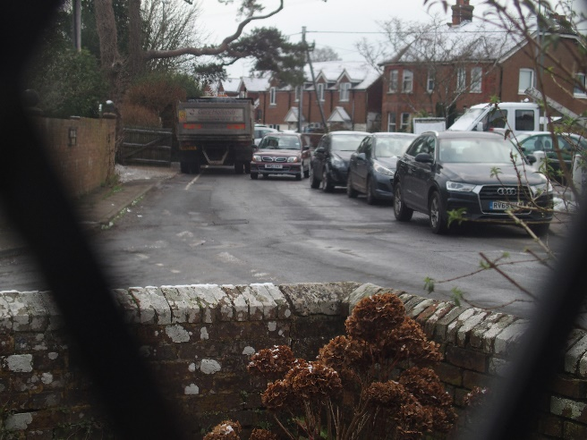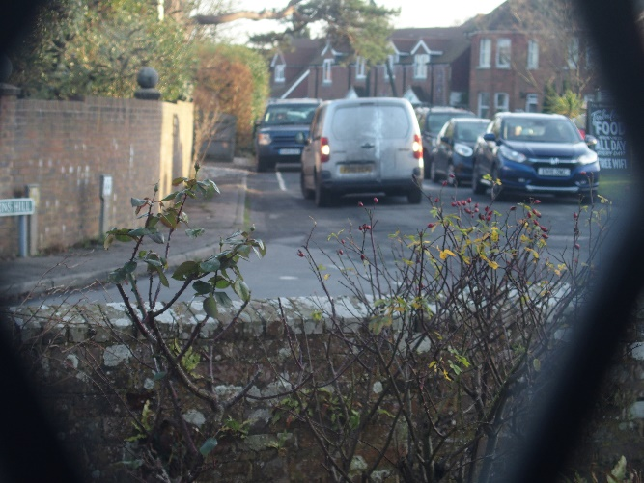
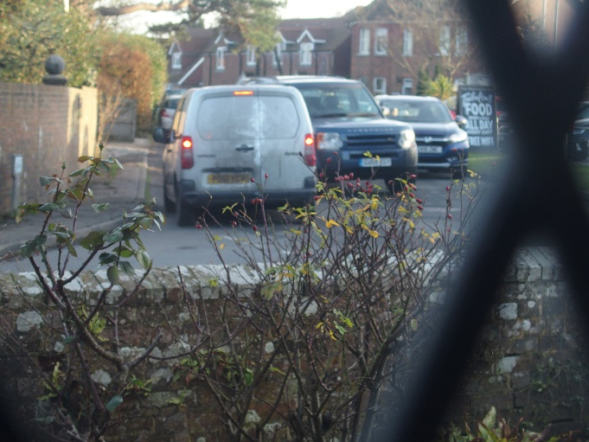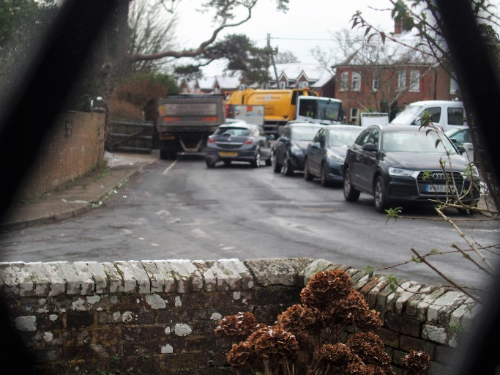
The Junction of Manchester Road and A269 by the Blacksmiths Pub.
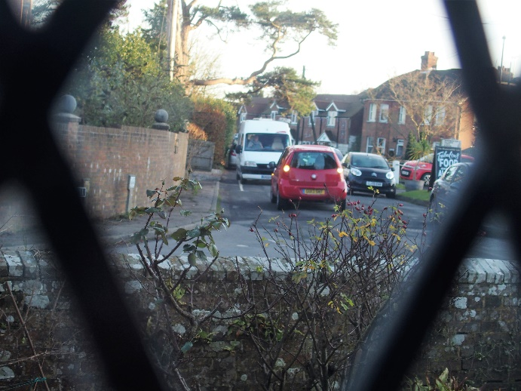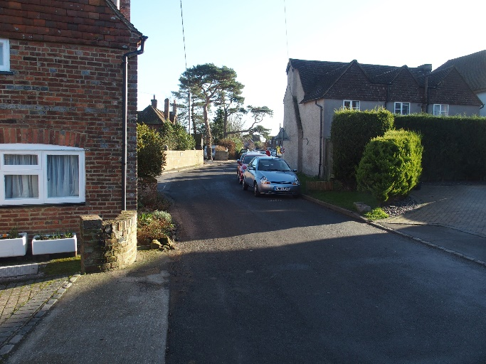
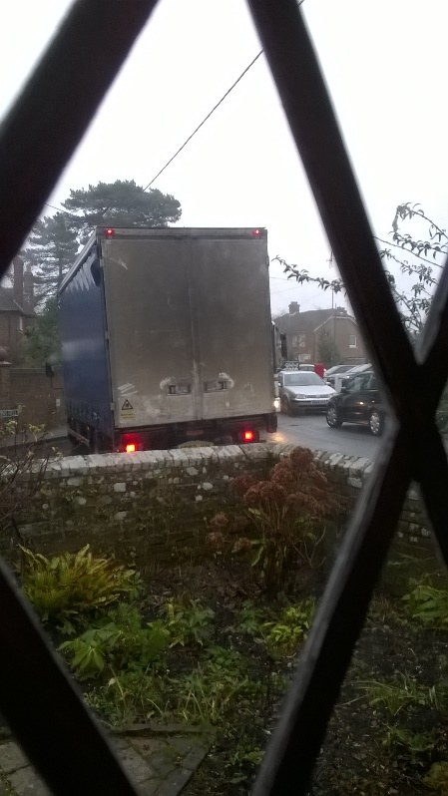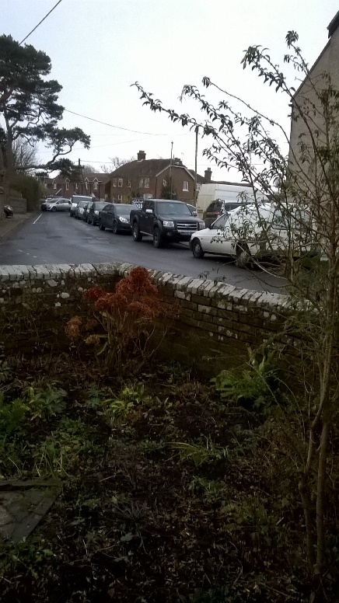
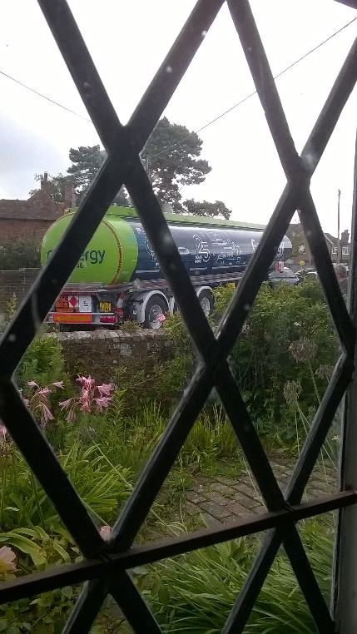
This tanker tried to pull out of Manchester Road on to the A269 but was unable to navigate round the parked cars. The driver reversed (with the aid of passing walkers into Moons Hill to go to the other end of Manchester Road and down Coombe Lane.

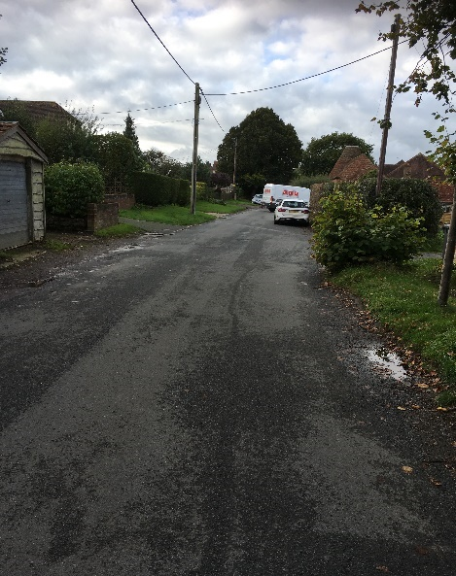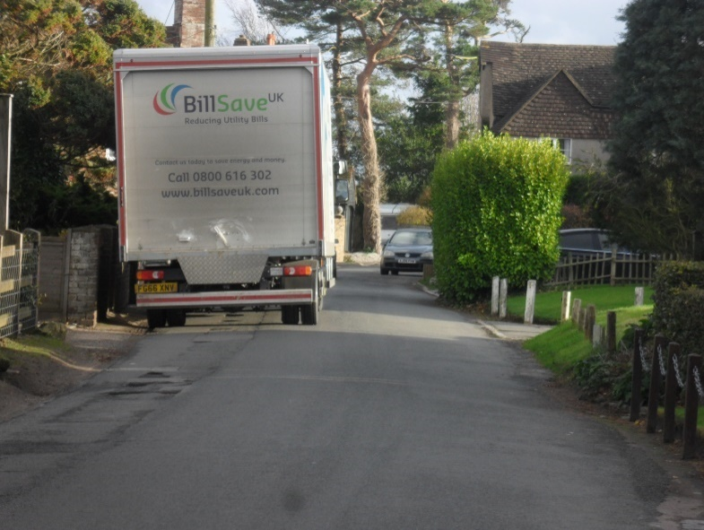
Van turning due to parked cars ahead

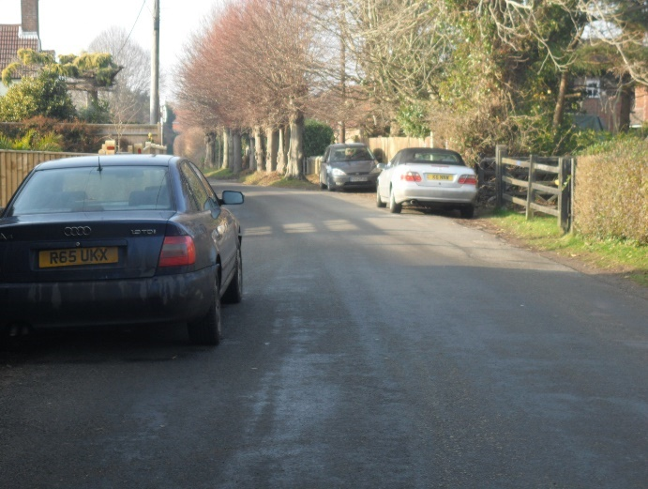
parked cars and the Ancient Lime Trees

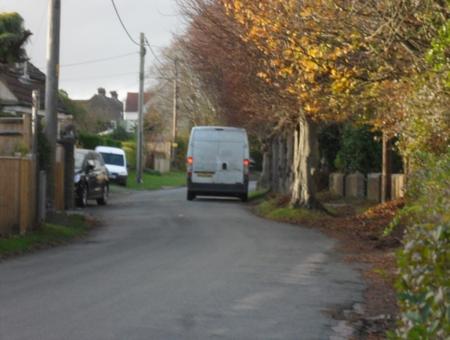
Van parked by the Lime Trees. Car can only pass using a resident’s driveway

